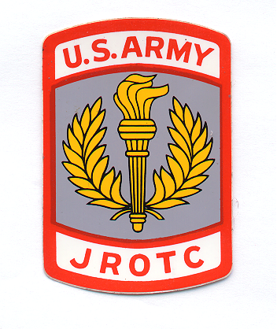
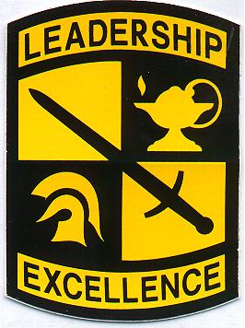
JUNIOR ROTC DEPARTMENT
WEST HENDERSON HIGH SCHOOL
3600 HAYWOOD ROAD
HENDERSONVILLE, NC 28791

12 January 2018
Dear Parent(s),
We are proud to have your son/daughter enrolled in the West Henderson High School JROTC program for the upcoming school year.
We want to make you aware that every time we travel outside of school, in order to conduct a parade, color guard or some other event we have to pay the transportation cost. Along with this is an accident insurance policy required for all Cadets. We are asking that each Cadet pay $20.00 to help cover this cost.
The JROTC program is governed by directives of the Henderson County School District and Army regulation 145-2. Unlike other academic courses, a JROTC cadet’s grade is not based solely on tests, but rather on a combination of academic, attitude, effort and performance ratings. A student with relatively low academic scores, but high performance and attitude scores, can pass the course.
Grading System:
- All course grades will be based upon the school grading system:

FINAL SCORE GRADE
90 - 100 A
80 - 89 B
70 - 79 C
60 - 69 D
0 - 59 F

- The percentage distribution used in determining the final score will be the following:

Conduct 20%
Uniform Inspection 30%
Physical Training 10%
Cadet Portfolio 10%
Test/Quizzes/Exams 30%

*PARTICIPATION will be used as their final exam grade which will be 20% of their overall grade.
Each Cadet must participate in at least 10 events during the semester to receive a grade of 100%. This will include on and off campus events.

JROTC uniforms and accessories are provided free of charge to all enrolled cadets. Once issued, the uniform becomes part of the grading process and the responsibility of the cadet to wear on prescribed uniform days and maintain the uniform i.e., laundry, cleaning, replacement of buttons, repairs, etc. Governing regulations require cadets to wear the uniform once a week, however the Cadets have the option of wearing the uniform during the JROTC class period only or all day. After the third (3) “failure to wear the uniform” the result will be failure of the class and disenrollment from the JROTC program.
We hold the Cadets accountable for the cost of replacement resulting from lost or damaged items through willful disregard or neglect. Parents or guardians must assume this accountability with the Cadet.
All cadets must comply with the established grooming policy concerning haircuts, earrings, nose rings, facial hair, etc. The grooming policy will be explained to each cadet during the first week of each semester.
Cadets who complete the program will develop a sense of responsibility, leadership, citizenship and character traits that will enable them to become responsible citizens in our society. They will learn to work cooperatively with others and respect authority.
Open Door Policy. Contact the instructor in the office, by phone, or by email at any time should you determine your child cannot or will have difficulty meeting the course requirements. If you do not understand any requirements of the course, or if you have any questions please feel free to contact us.
Again, we are proud to have your son/daughter in our program. I look forward to meeting you. I would appreciate your signature showing receipt and understanding of this letter. Please return it to the JROTC department. Thank You.

__________________________ Randy C. Lytle
Parent Signature LTC (R), US Army
Senior Army Instructor

“Motivating Young People to Become Better Citizens”

